Law Library of the National and Kapodistrian University of Athens (NKUA)

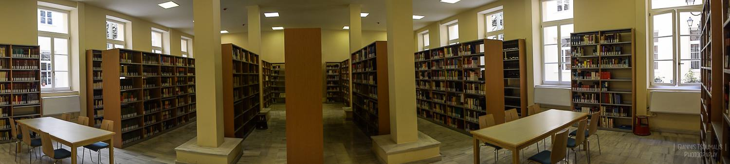

The Law Library of the National and Kapodistrian University of Athens (NKUA) is one of the oldest libraries of the NKUA. The Library contains a valuable collection of law books and journals, covering all branches of domestic and International law. The Library relocated in October 2016 in the historic building of the “Old Chemistry Laboratory” of the NKUA, an architectural masterpiece and an important monument of the city of Athens. It provides to members of the Law School community easy, integrated access to legal information in all formats.

It also covers, supports and promotes academic activities of both undergraduate and postgraduate programs of the Institution. Moreover, the Library is equally supporting the humanitarian and cultural role of the NKUA.

Library’s website: http://law.lib.uoa.gr
Access to online catalog: http://www.lib.uoa.gr

Tel.: (+30)2103688065
Email: nomiki@uoa.gr
Address: 104, Solonos & 17, Mavromichali St. Athens,106 80
Opening hours: Monday - Friday 08:30 - 19:00

